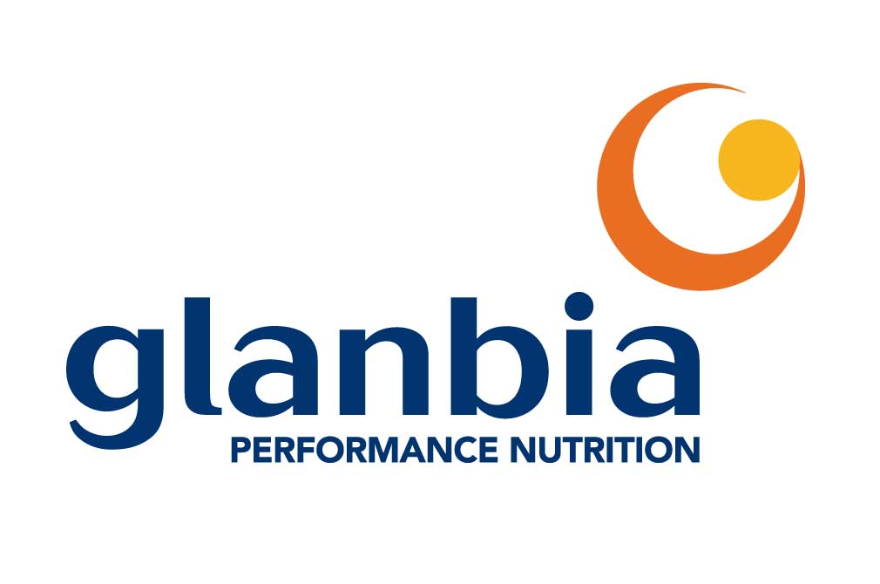
Job Description

Job Title:  Consumer and Sensory Scientist | Job Code:
Reports To (Manager Title):  R&D Consumer & Sensory Science Manager | FLSA:
Supervising Responsibility:  Technician | Salary Structure:
Work Location:  Downers Grove, IL | Grade/Band:
Job Summary:
- Glanbia Performance Nutrition (GPN) is a global leader in the development, manufacturing & marketing of sports and nutrition solutions. The company is headquartered in Downers Grove, IL and markets products under its own brands and for many of the leading brands of sports and wellness products through the world. This exciting business continues to grow rapidly and is currently seeking a Consumer and Sensory Scientist to join the sensory group in R&D. This position will be accountable for consulting with R&D to design studies to meet their sensory testing requirements, creating test questionnaires, conducting statistical data analysis and writing reports with recommendations, as needed. Additionally, it will be responsible for working with outside agencies when applicable, developing and delivering sensory trainings, as well as leading the GPN Stability Program. GPN is a wholly owned subsidiary of Glanbia, a multi-national nutritionals, dairy and food products business headquartered in Ireland.

Essential Functions:
- Consults with Product Development on Innovation projects to design studies to meet their sensory testing requirements; executes testing, as needed.
- Consults with Second Sourcing and Productivity Teams to design sensory testing to ensure there is no perceivable change in finished good quality as raw materials and/or processes are evaluated for approval.
- Manages, organizes and tracks multiple sensory projects.
- Creates sensory test questionnaires in Compusense, conducts statistical analysis and interprets data, as needed to support the R&D Team.
- Supports final report creation by providing lead with overall results and comments from testing; writes reports and presents results to the R&D/Marketing Teams, as needed.
- Develops sensory best practice protocols and delivers trainings to the Team, as needed.
- Leads the flavor and texture training for panelists; provides refresher trainings as needed.
- Works with Sensory Manager to set up discrimination screening and tracks panelist performance.
- Leads recruitment and orientation for new GPN panelists.
- Manages the Stability Program from initial meeting with requestor through final data entry into tracker; responsible for facilitating chamber maintenance.
- Partners with global GPN colleagues to align on sensory methodologies and best practices.
- Responsible for maintaining the sensory kitchen and assuring all required testing items are stocked and available.
- Assures safety protocols are in place and enforced.

Knowledge, Skills and Abilities: Basic information of the position
- A self-starter with the ability to work autonomously.
- Proficiency in food science or experience with food products with interest in growth in the food sensory sciences
- Working knowledge in the application of sensory (descriptive, discrimination), consumer research (CLT, HUT, focus groups) and statistics in a FMCG/CGP commercial environment.
- Expertise in Sensory Descriptive Analysis and ability to train Descriptive Panels.
- Proficient in statistical analysis with understanding of Design of Experiments (DOE), key driver analysis, and multivariate statistics.
- Experience using sensory software (Compusense, FIZZ, Xlstat); Compusense proficiency a plus.
- Proficient in Microsoft Office (Word, Excel, Outlook, PowerPoint).
- Strong analytical and organizational skills, and detail-oriented.
- Excellent communication and written English skills.
- Strong team orientation and ability to work in cross-functional teams.
- Ability to manage projects to deadlines and make decisions in a timely manner.
- Comfortable communicating with all levels of management.
- Flexibility and ability to stay focused as priorities change.

Competencies: Basic competencies of the position
- Learning on the Fly- Learns quickly when faced with a new problem; quickly grasps the essence of the situation.
- Attention to Detail – Demonstrates thoroughness and accuracy when accomplishing a task; considers all areas involved to ensure that small details are not overlooked.
- Problem Solving- “Thinks outside the box” to find solutions and can see hidden problems.
- Dealing with Ambiguity- Can comfortably handle risk and uncertainty.
- Self-Development –Personally committed to actively working toward continuous improvement; acts on constructive feedback and puts in effort to grow & change.
- Ability to Prioritize – Can focus on critical activities and put aside trivial/what’s nice to do; eliminates roadblocks.
- Composure – Can handle stress and is calm under pressure; does not become overly emotional.
- Interpersonal Savvy – Relates well to people at all levels, both internal and external to the organization.
- Mentoring and Influencing Others- Supports the development of others (e.g. Compusense assistance, sensory trainings, mentoring more junior level employees).

Decision Making/ Problem Solving: Give at least 3 examples of the types of decisions this job will typically make without higher level approval.
- Determining and optimizing sensory testing to collect a variety of information required for product optimization, second sourcing of ingredients and developing drivers of liking of sports nutrition products.

- Identify appropriate internal panels/panelists for various types of testing during the product development phase of the product lifecycle.

- Deal with ambiguity and make decisions when clear answers are not available.

Education/Experience:
- Education/Experience: B.S. in a science field with 5+ years working independently in a food sensory lab or M.S. in Food Science with 1+ years’ experience in a food sensory lab.
- Active member of at least one key professional organization including ASTM, IFT, Pangborn, Sensometrics, Society of Sensory Professionals, etc…

PHYSICAL DEMANDS: (The work is classified as Light - Medium Physical Demand Level (PDL) by the US Dept. of Labor’s Dictionary of Occupational Titles.)
Frequencies: Occasional (1-33%); Frequent (34-66%); Continuous (67-100%)
Please change the Physical Demands to fit each job as needed.

Lifting Demands | Pounds
Lift on an occasional basis floor to waist | 15
Carry on an occasional basis up to 25 feet | 15
Postural Demands | Frequency
Sitting | Occasional
Standing | Frequent
Walking | Frequent
Bending/stooping | Occasional

Essential Competencies Identified for position (Do not complete this section; HR will complete):

Basic:
Experienced:
Developmental:

NOTE: This job description is not intended, nor should it be construed to be an exhaustive list of all responsibilities, duties, skills, or working conditions associated with the particular job. It is intended only to be a general description of the essential functions common to positions of this type.

(Do not complete this section; HR will complete):
Revision Date | Written by | Revision
06/01/2014 | HR | New Job Description OR
10/01/2014 | HR | Updated the content of the job description to reflect the most current documentation practices

Approvals:
Department | Name & Title | Date
XXX
HR

